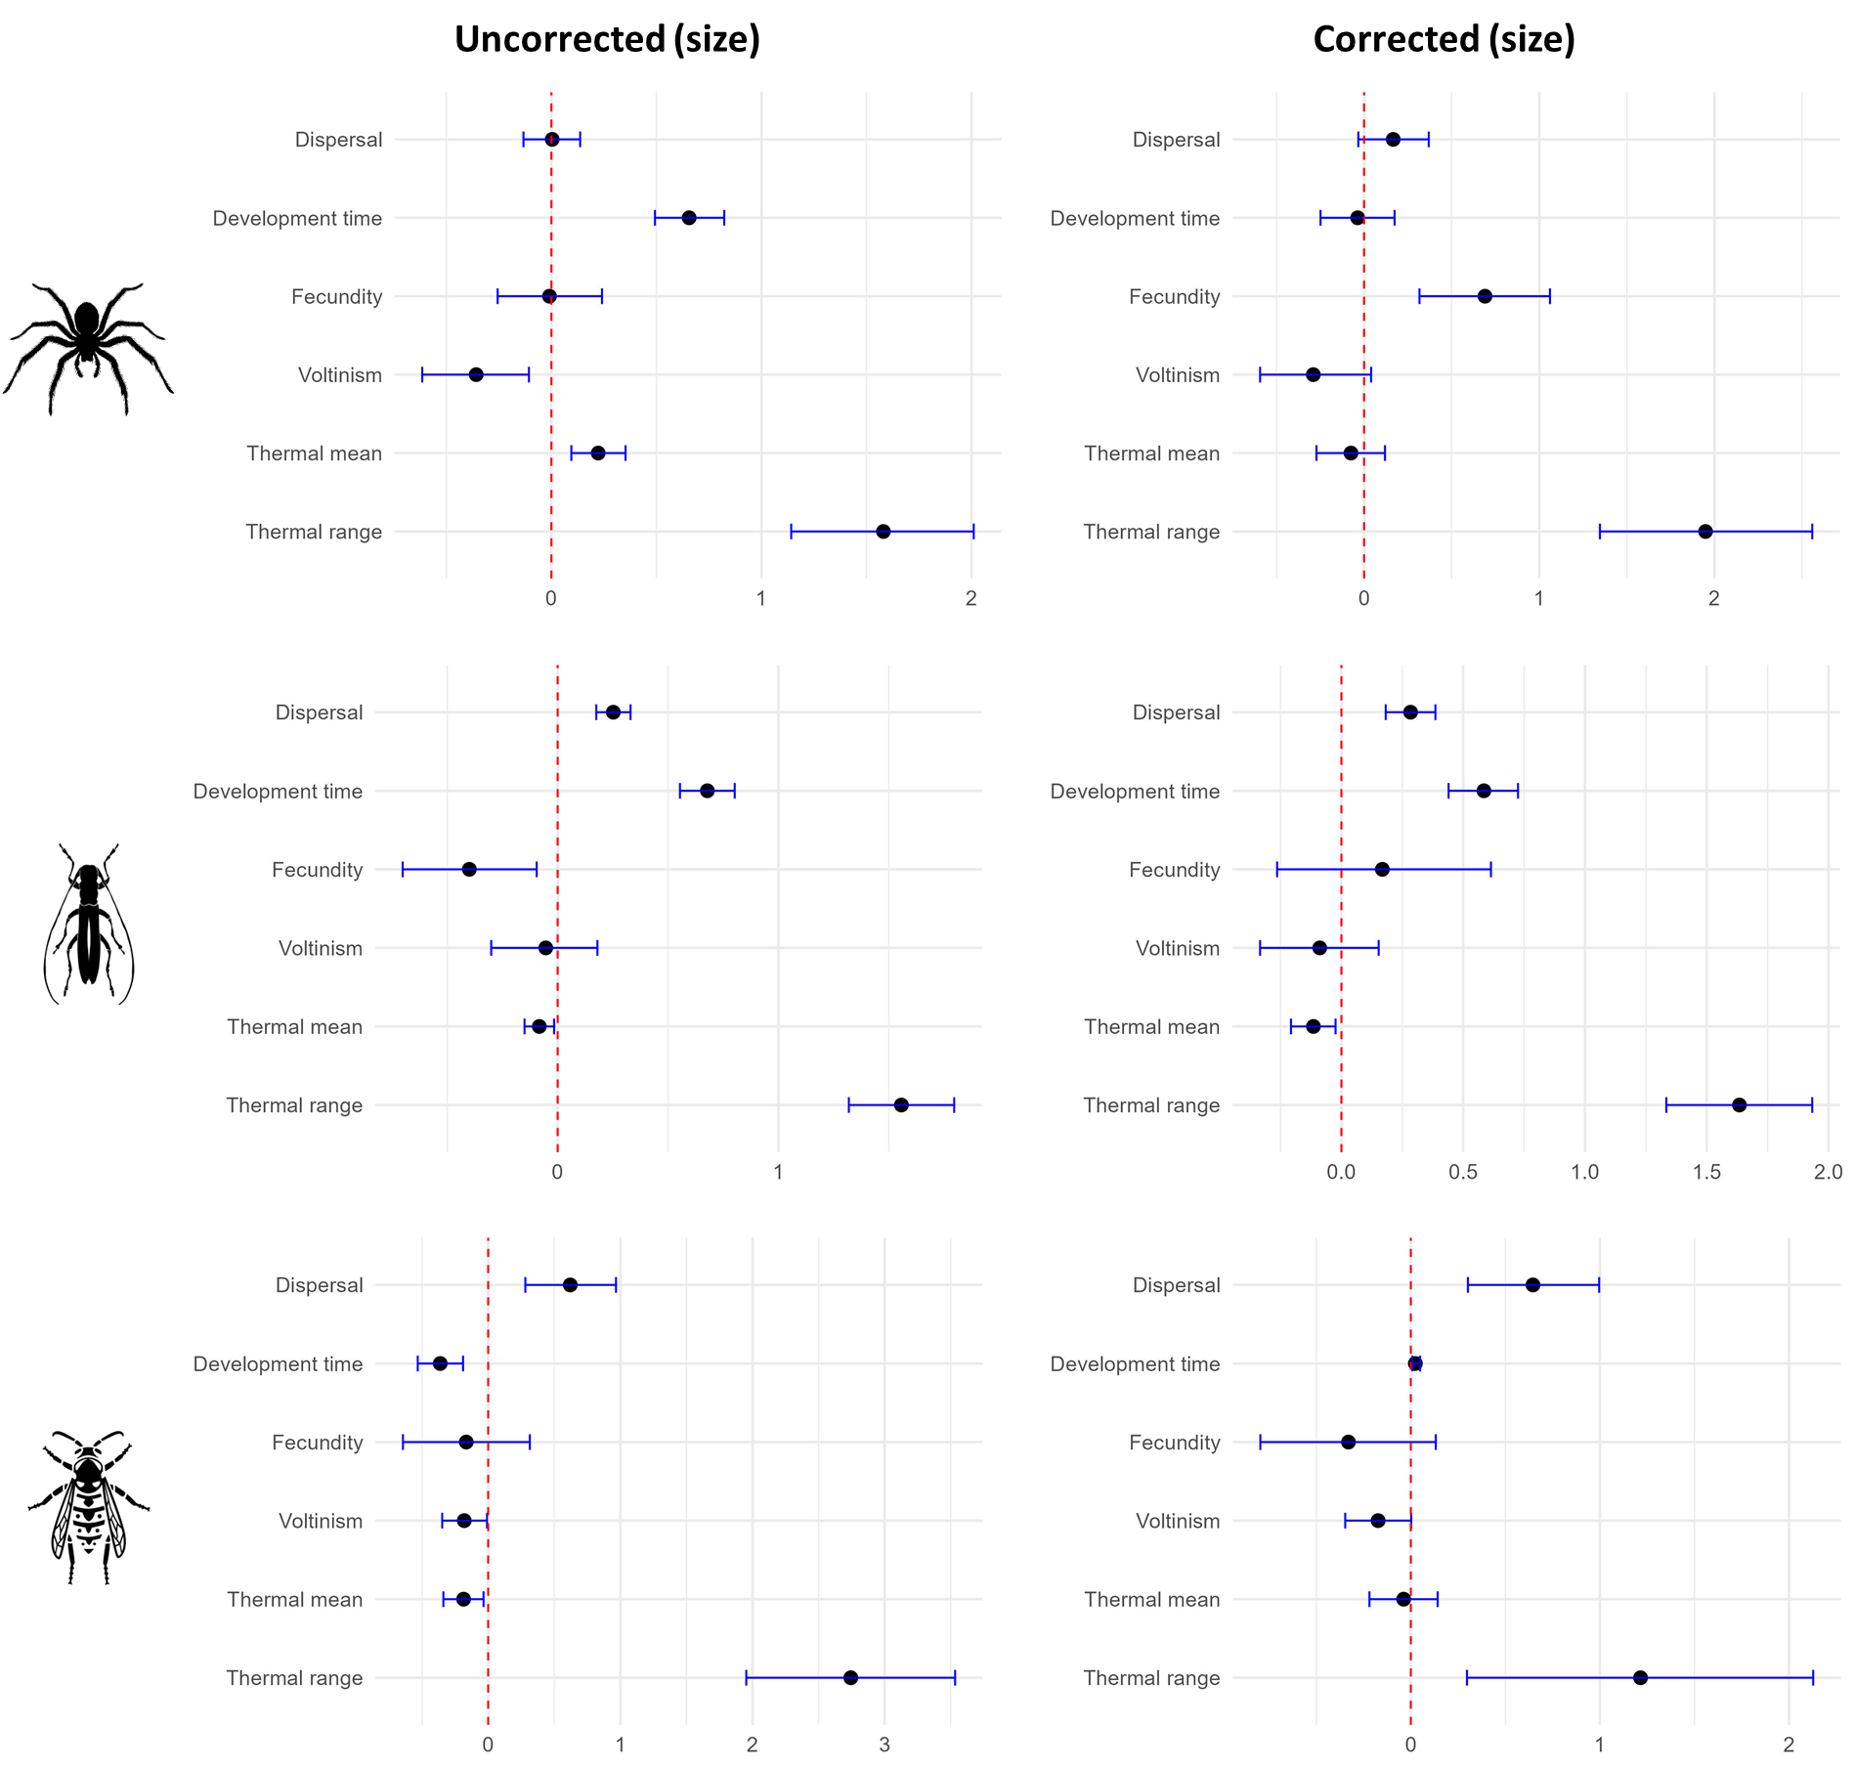
S.3.2 Comparison between corrected and uncorrected models
Figure S.3.2.1a: comparison of uncorrected (left) and phylogenetically corrected (right) correlations with size for spiders, beetles and hymenopterans. Each point represents the correlation estimate with size as the independent variable and the corresponding trait as dependent variable. The error bars represent the 95% credibility intervals.
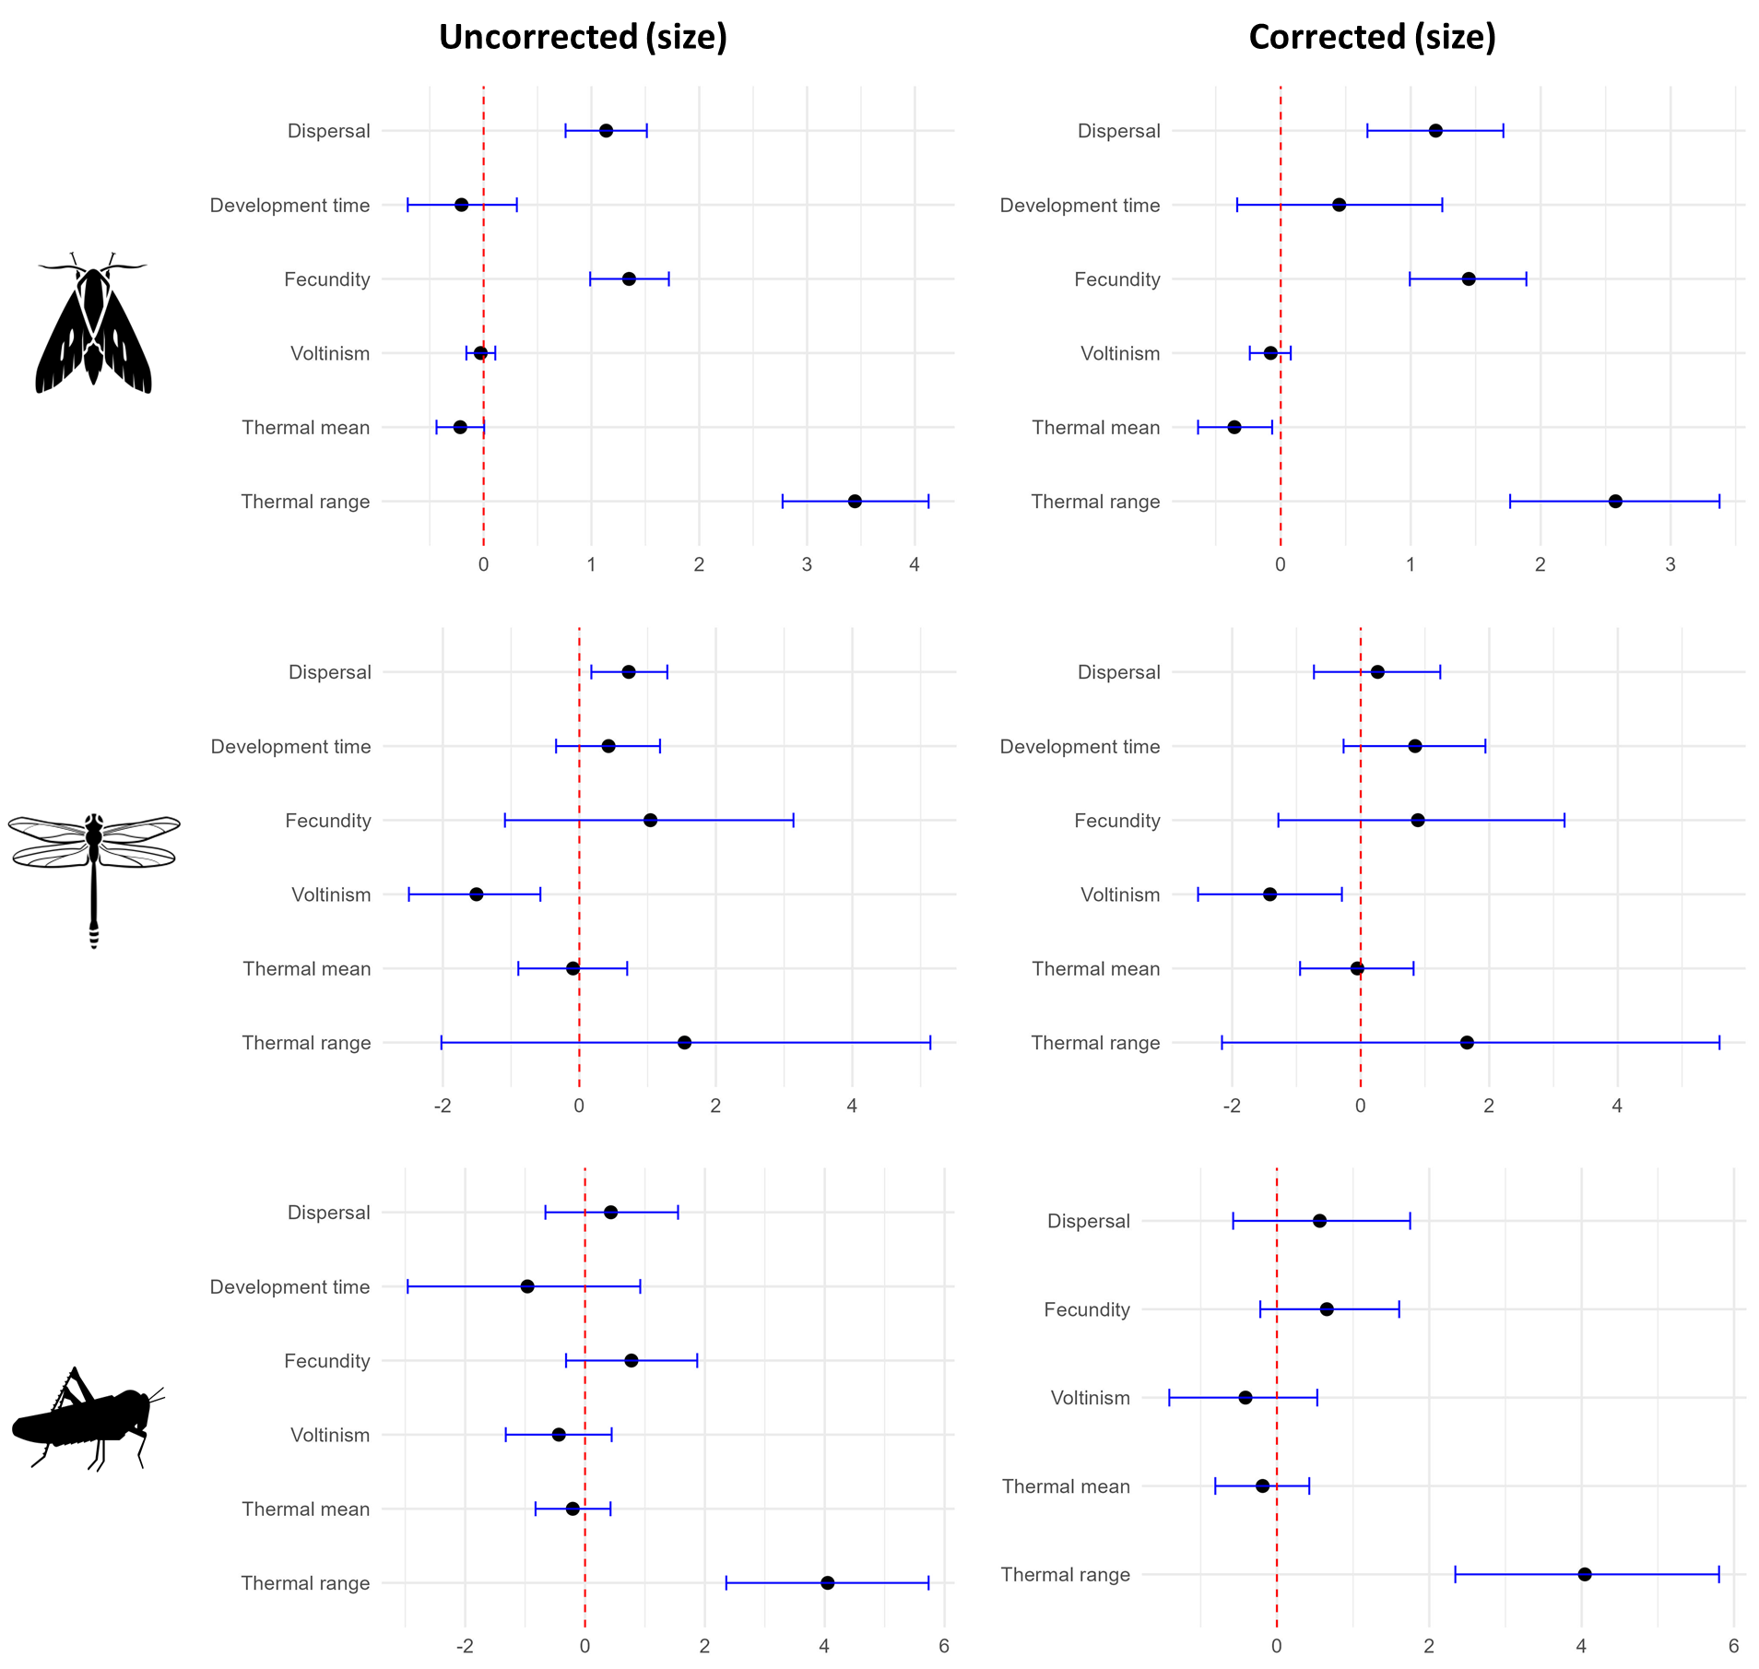
Figure S.3.2.1b: comparison of uncorrected (left) and phylogenetically corrected (right) correlations with size for butterflies, dragonflies and grasshoppers. Each point represents the correlation estimate with size as the independent variable and the corresponding trait as dependent variable. The error bars represent the 95% credibility intervals.

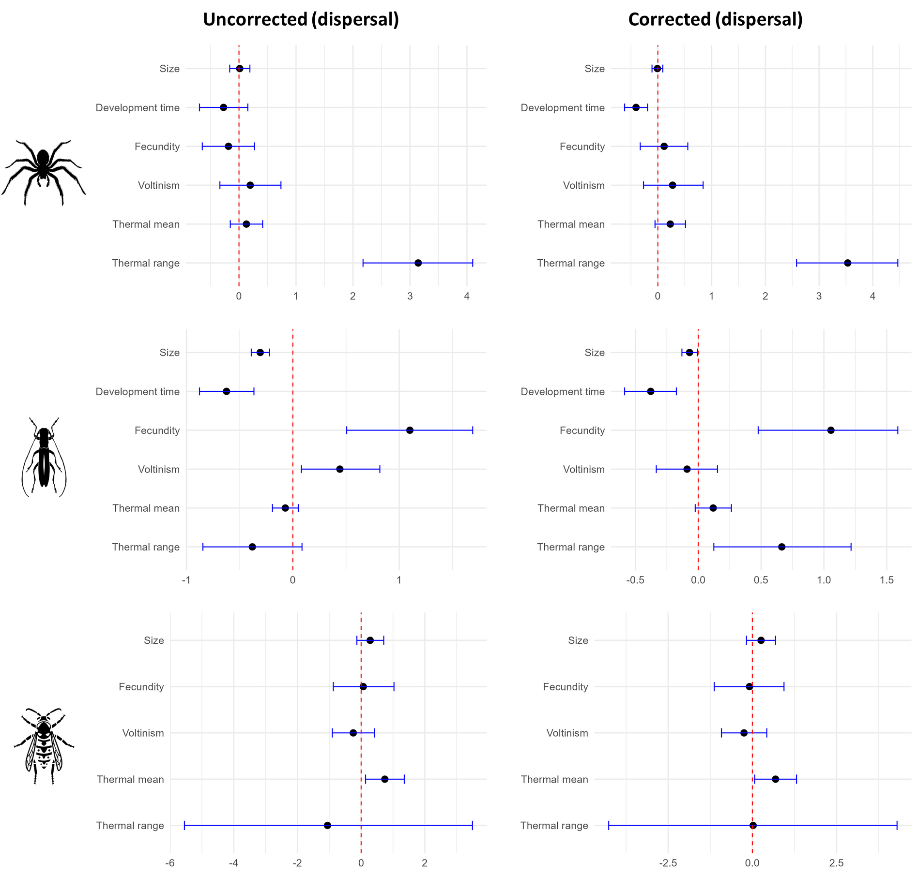
Figure S.3.2.2a: comparison of uncorrected (left) and phylogenetically corrected (right) correlations with dispersal for spiders, beetles and hymenopterans. Each point represents the correlation estimate with dispersal as the independent variable and the corresponding trait as dependent variable. The error bars represent the 95% credibility intervals.

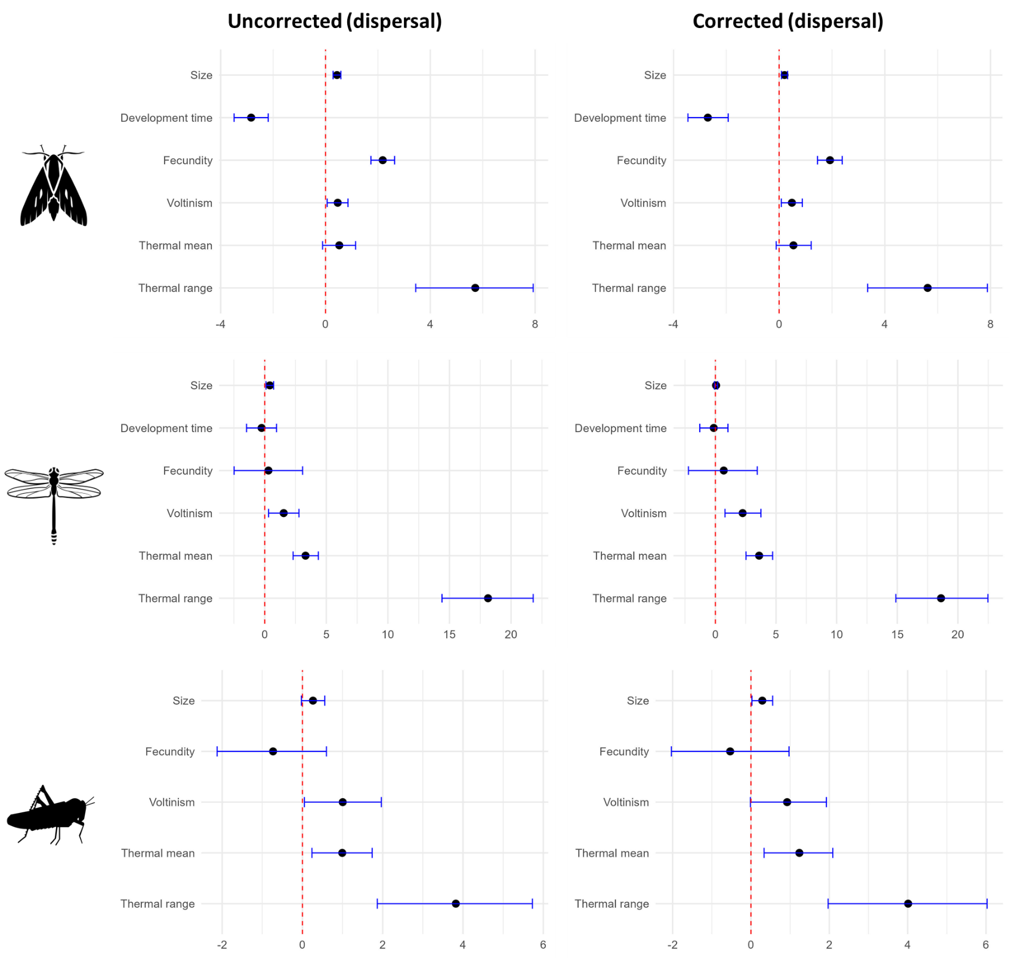
Figure S.3.2.2b: comparison of uncorrected (left) and phylogenetically corrected (right) correlations with dispersal for butterflies, dragonflies and grasshoppers. Each point represents the correlation estimate with dispersal as the independent variable and the corresponding trait as dependent variable. The error bars represent the 95% credibility intervals.
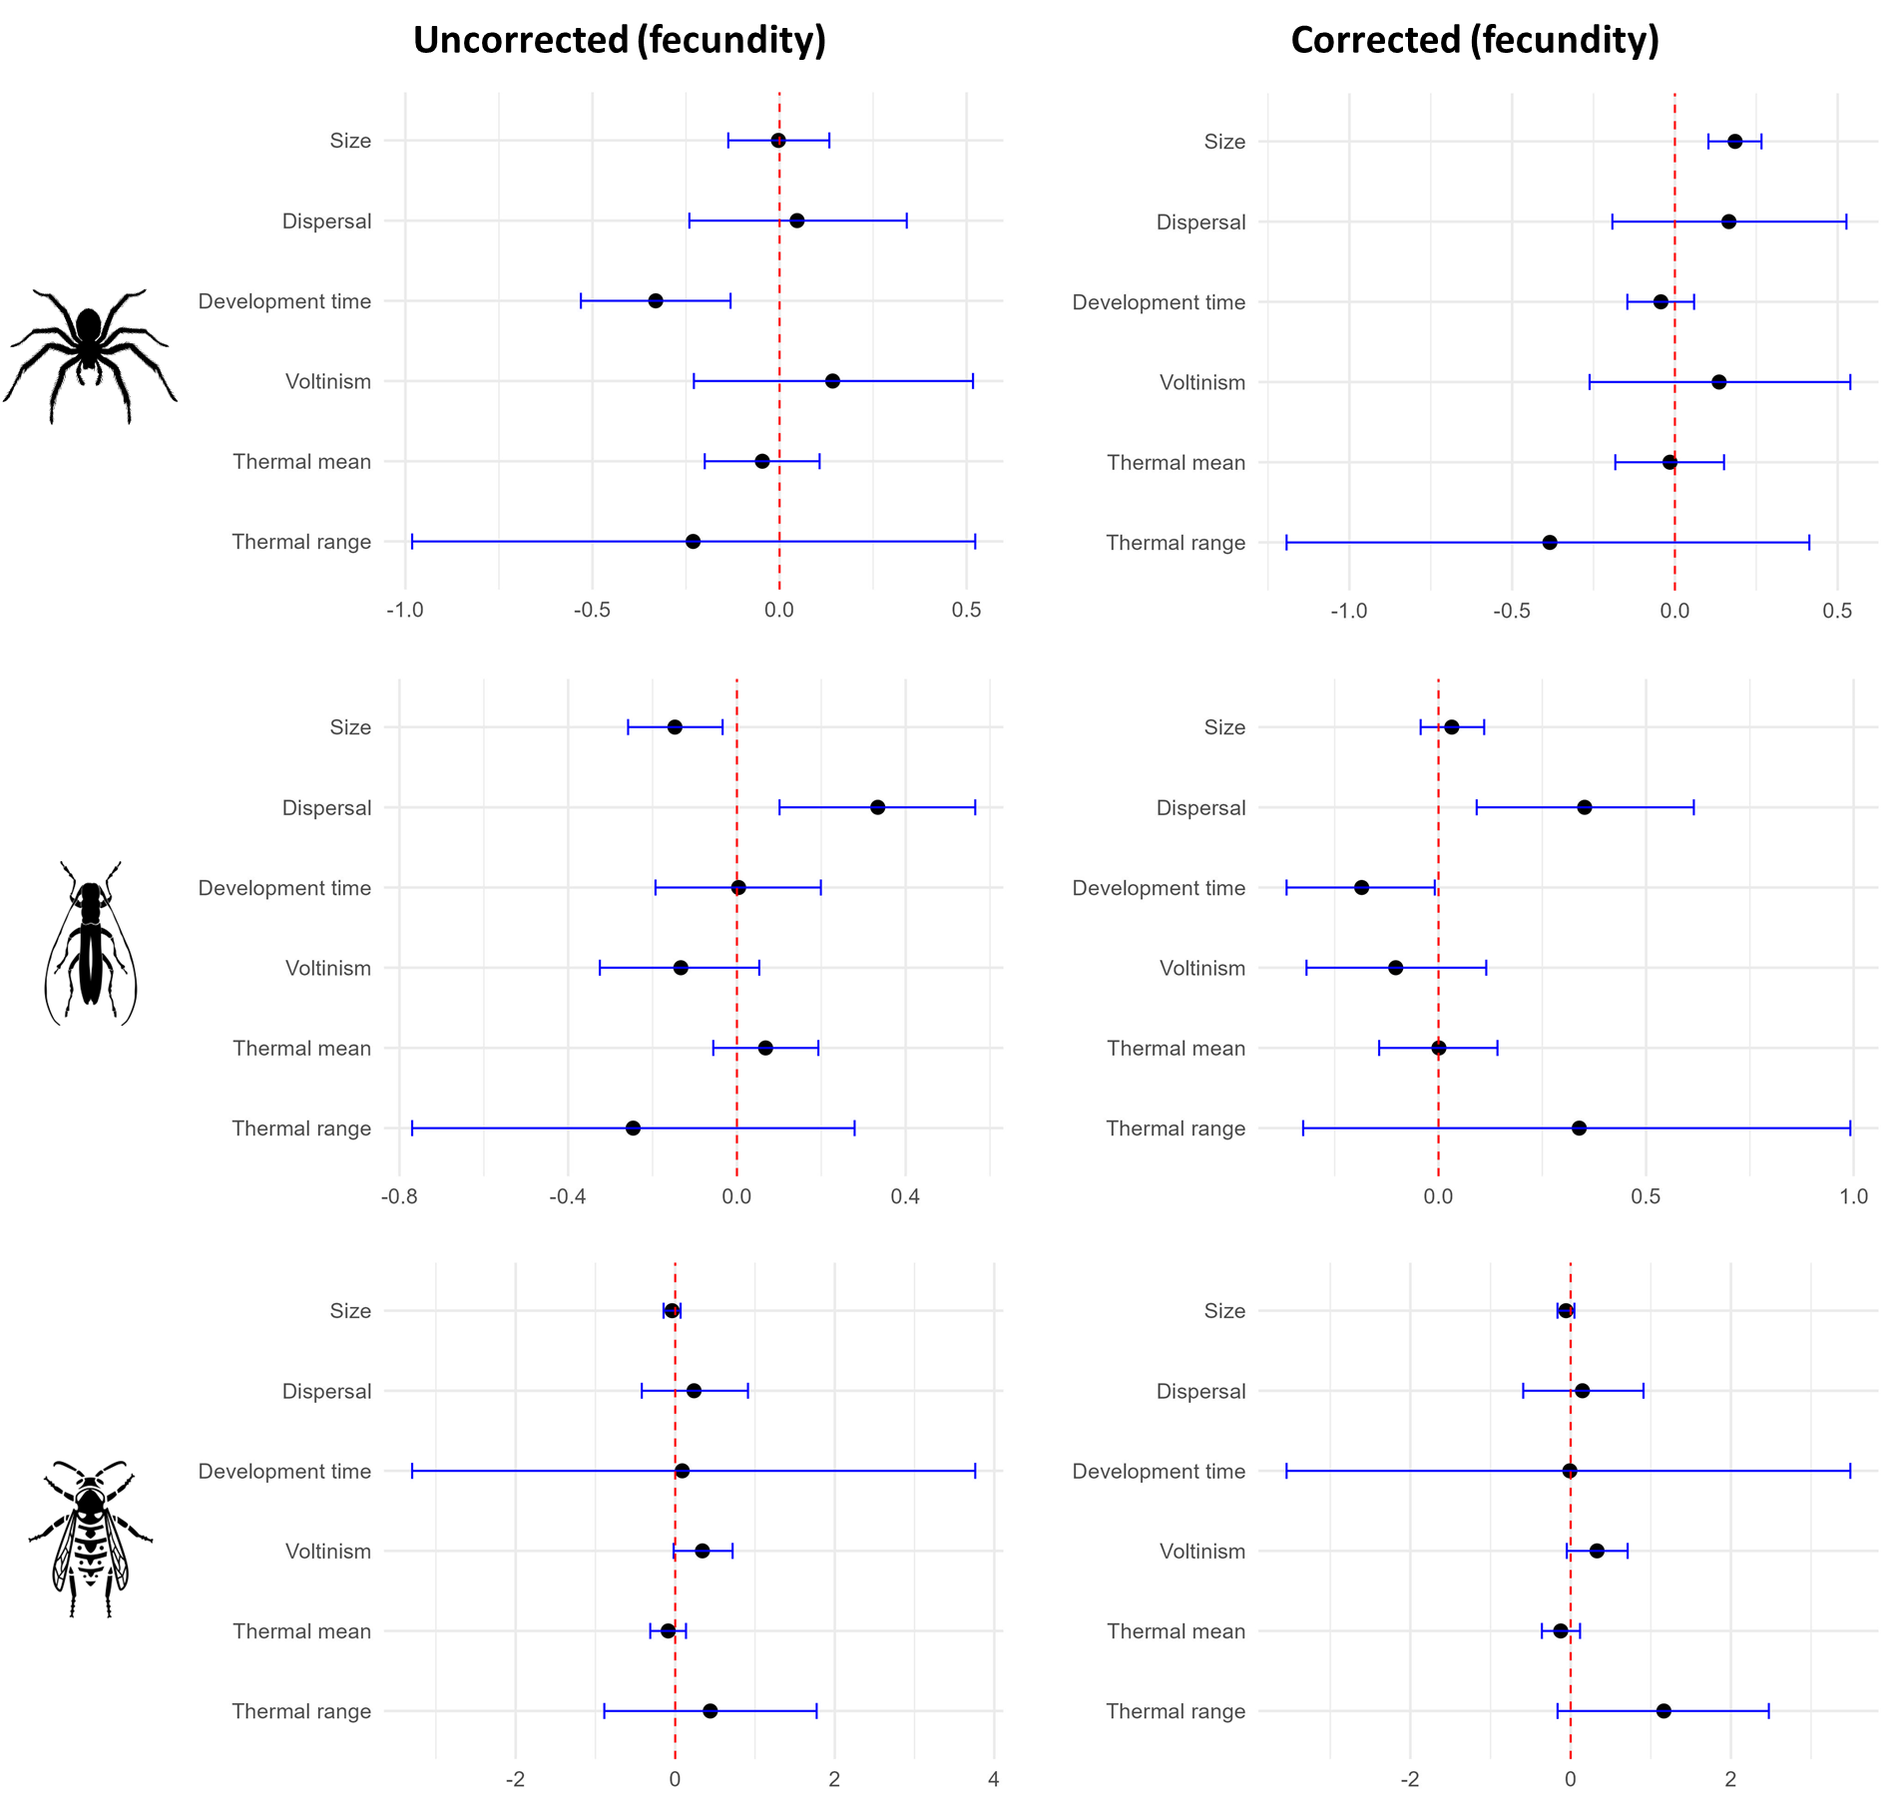
Figure S.3.2.3a: comparison of uncorrected (left) and phylogenetically corrected (right) correlations with fecundity for spiders, beetles and hymenopterans. Each point represents the correlation estimate with fecundity as the independent variable and the corresponding trait as dependent variable. The error bars represent the 95% credibility intervals.

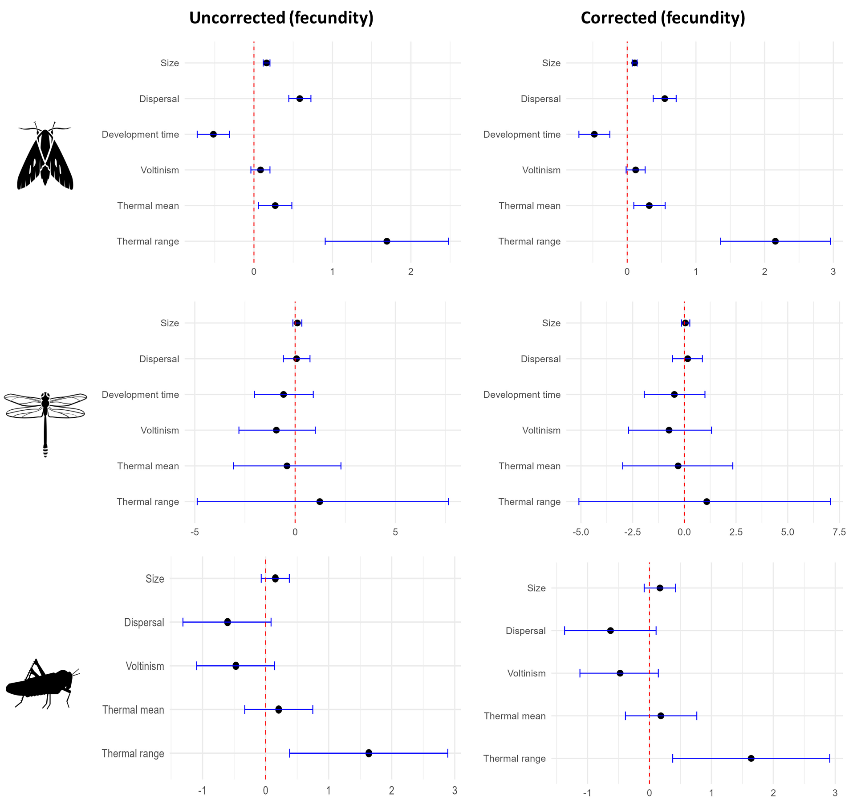
Figure S.3.2.3b: comparison of uncorrected (left) and phylogenetically corrected (right) correlations with fecundity for butterflies, dragonflies and grasshoppers. Each point represents the correlation estimate with fecundity as the independent variable and the corresponding trait as dependent variable. The error bars represent the 95% credibility intervals.

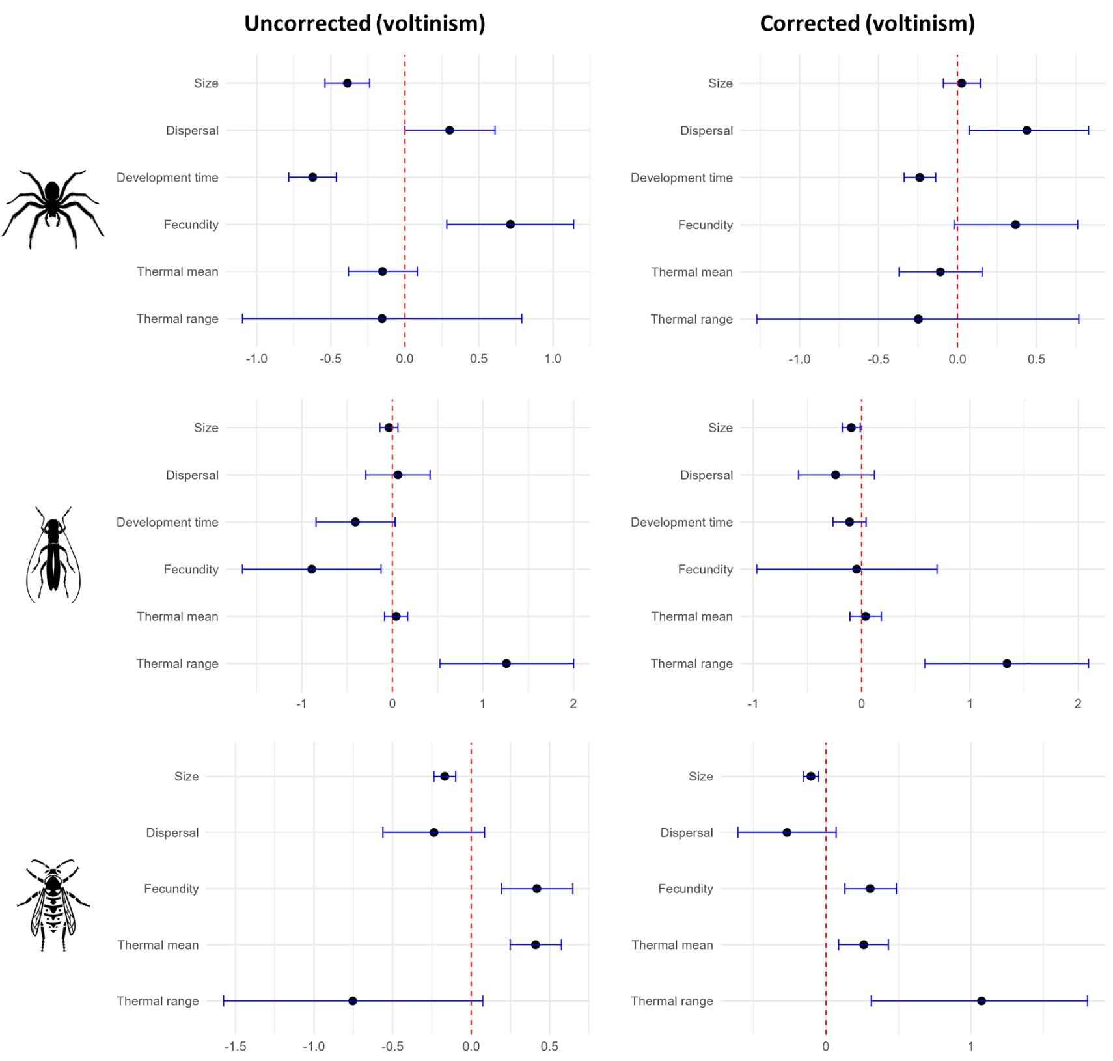
Figure S.3.2.4a: comparison of uncorrected (left) and phylogenetically corrected (right) correlations with voltinism for spiders, beetles and hymenopterans. Each point represents the correlation estimate with voltinism as the independent variable and the corresponding trait as dependent variable. The error bars represent the 95% credibility intervals.
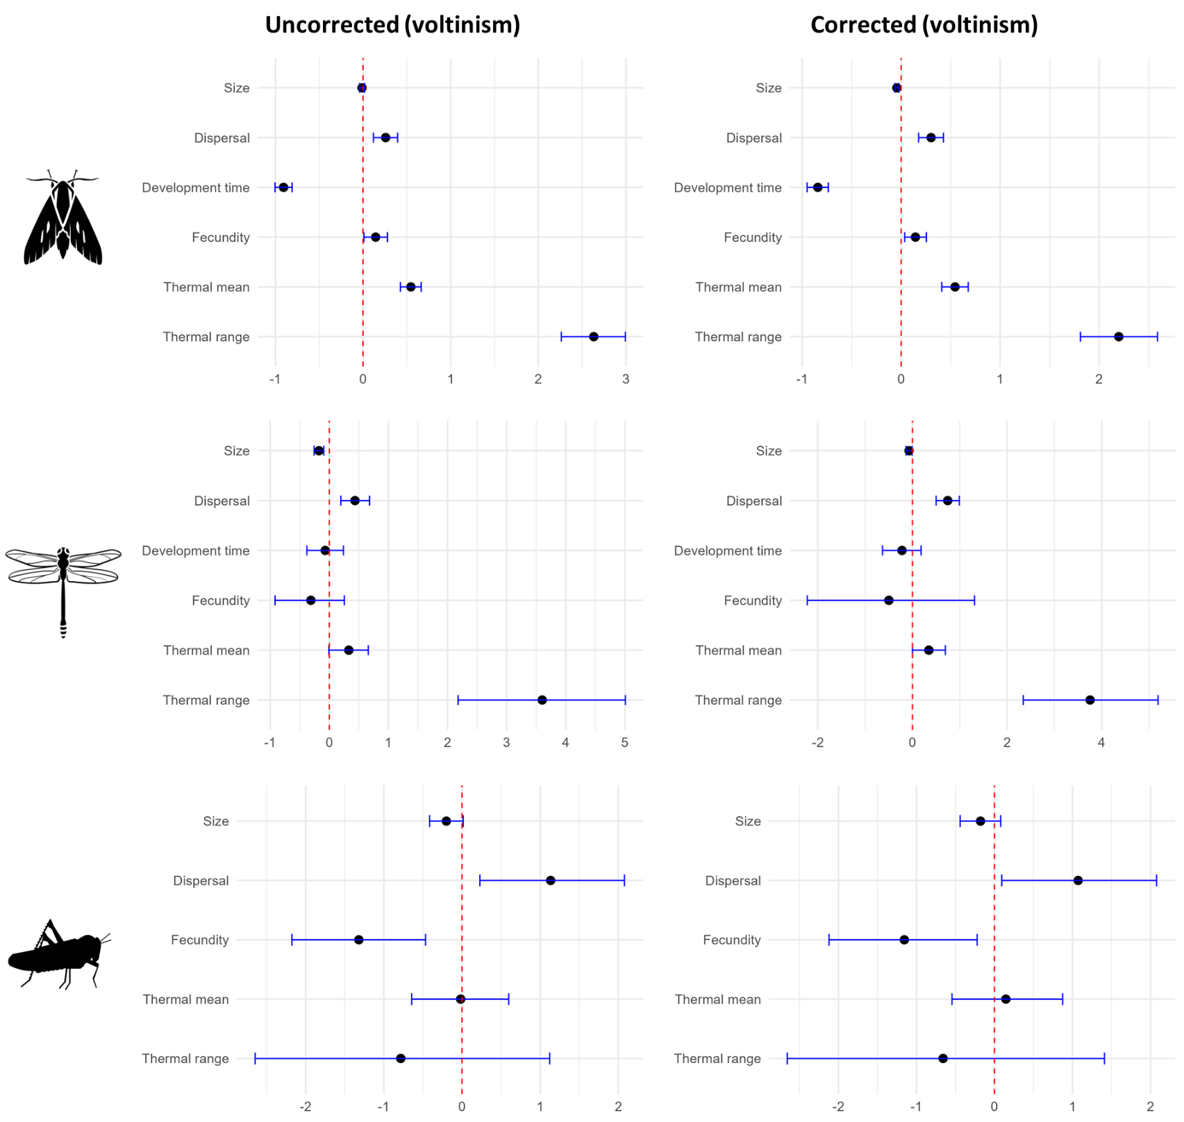
Figure S.3.2.4b: comparison of uncorrected (left) and phylogenetically corrected (right) correlations with voltinism for butterflies, dragonflies and grasshoppers. Each point represents the correlation estimate with voltinism as the independent variable and the corresponding trait as dependent variable. The error bars represent the 95% credibility intervals.
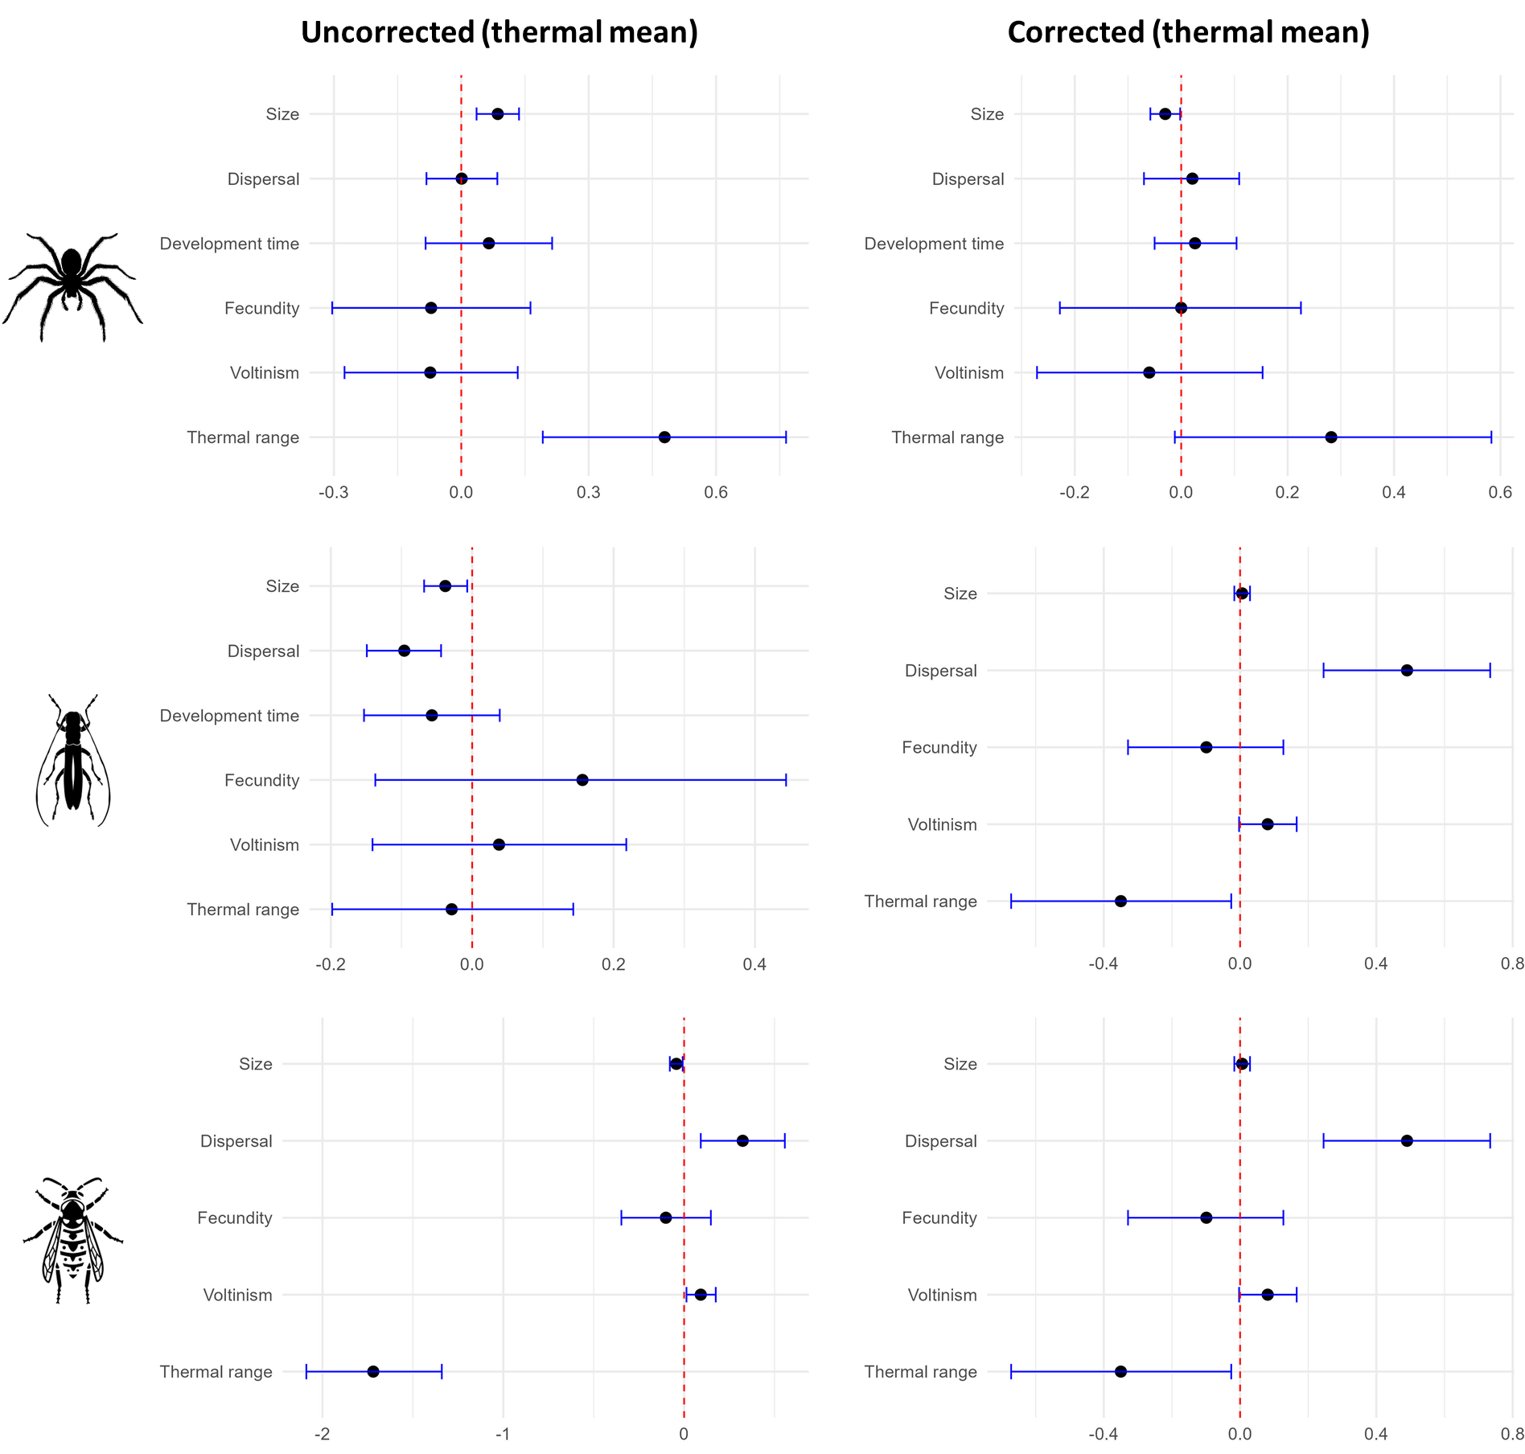
Figure S.3.2.5a: comparison of uncorrected (left) and phylogenetically corrected (right) correlations with thermal mean for spiders, beetles and hymenopterans. Each point represents the correlation estimate with thermal mean as the independent variable and the corresponding trait as dependent variable. The error bars represent the 95% credibility intervals.

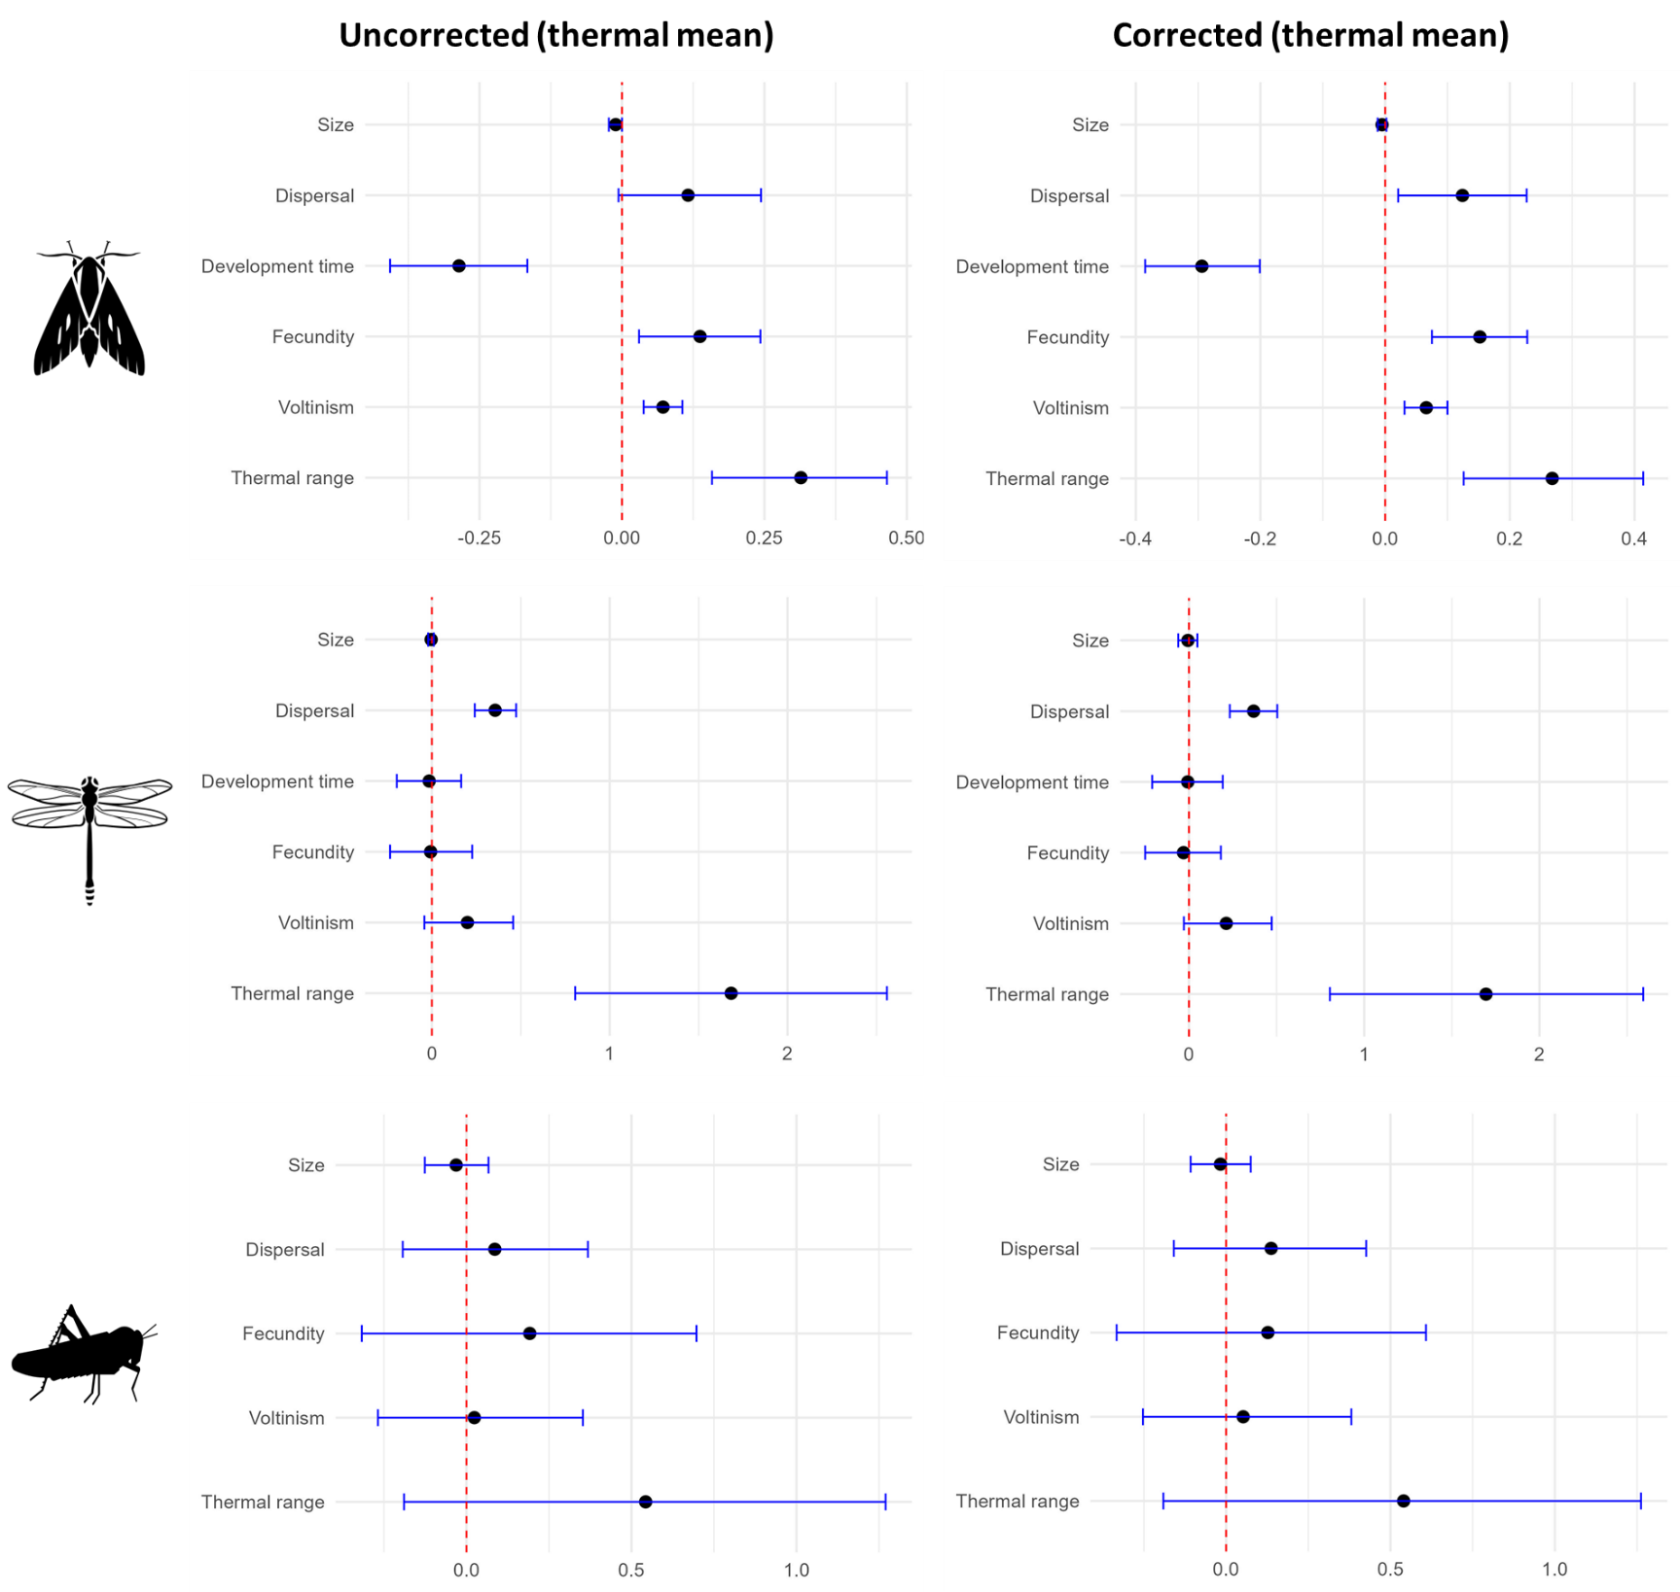
Figure S.3.2.5b: comparison of uncorrected (left) and phylogenetically corrected (right) correlations with thermal mean for butterflies, dragonflies and grasshoppers. Each point represents the correlation estimate with thermal mean as the independent variable and the corresponding trait as dependent variable. The error bars represent the 95% credibility intervals.

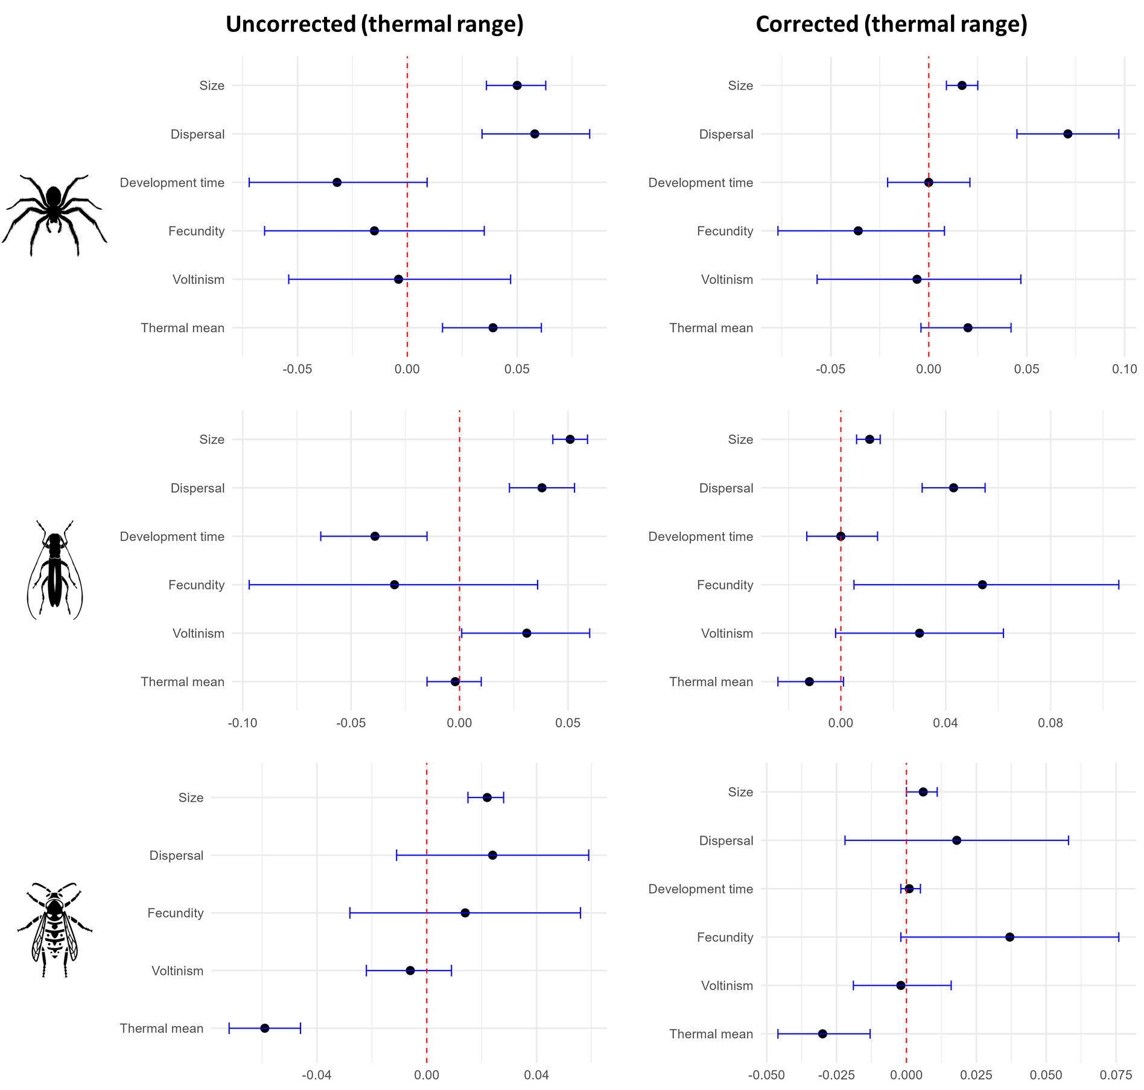
Figure S.3.2.6a: comparison of uncorrected (left) and phylogenetically corrected (right) correlations with thermal range for spiders, beetles and hymenopterans. Each point represents the correlation estimate with thermal range as the independent variable and the corresponding trait as dependent variable. The error bars represent the 95% credibility intervals.

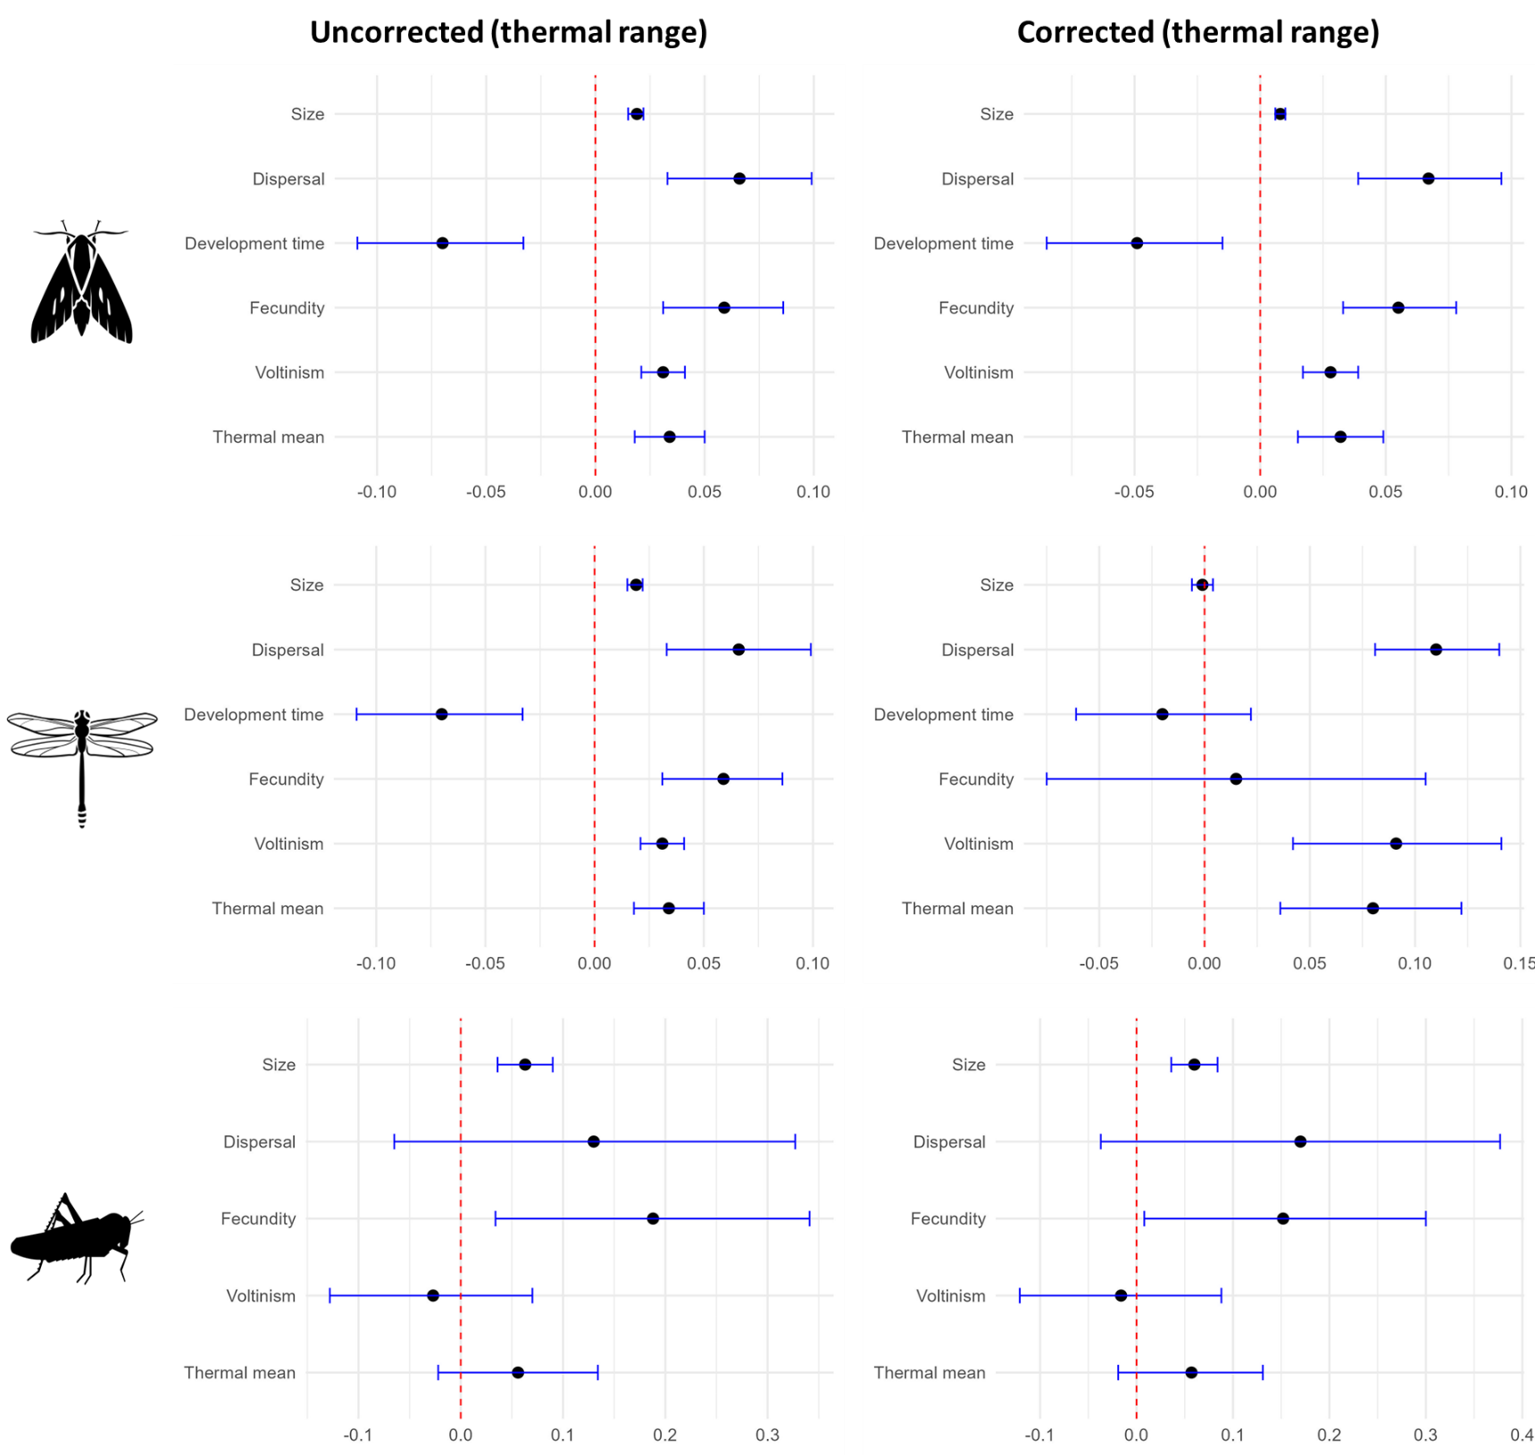
Figure S.3.2.6b: comparison of uncorrected (left) and phylogenetically corrected (right) correlations with thermal range for butterflies, dragonflies and grasshoppers. Each point represents the correlation estimate with thermal range as the independent variable and the corresponding trait as dependent variable. The error bars represent the 95% credibility intervals.

